**What is deep learning?**

**Ans:** Deep learning is a branch of [machine learning](https://www.geeksforgeeks.org/introduction-machine-learning/) which is completely based on [artificial neural networks](https://www.geeksforgeeks.org/tag/neural-network/), as neural network is going to mimic the human brain so deep learning is also a kind of mimic of human brain. In deep learning, we don’t need to explicitly program everything. The concept of deep learning is not new. It has been around for a couple of years now. It’s on hype nowadays because earlier we did not have that much processing power and a lot of data. As in the last 20 years, the processing power increases exponentially, so, deep learning and machine learning came in the picture.

**Another definition?**

**Ans:** *Deep learning is a particular kind of machine* learning *that achieves great power and flexibility by learning to represent the world as a nested hierarchy of concepts, with each concept defined in relation to simpler concepts, and more abstract representations computed in terms of less abstract ones.*

**What is Activation function?**

**Ans:** Simply put, an activation function is a function that is added into an artificial neural network in order to help the **network learn complex patterns in the data**. When comparing with a neuron-based model that is in our brains, the activation function is at the end deciding **what is to be fired to the next neuron**. That is exactly what an activation function does in an ANN as well. **It takes in the output signal from the previous cell and converts it into some form that can be taken as input to the next cell**. The comparison can be summarized in the figure below

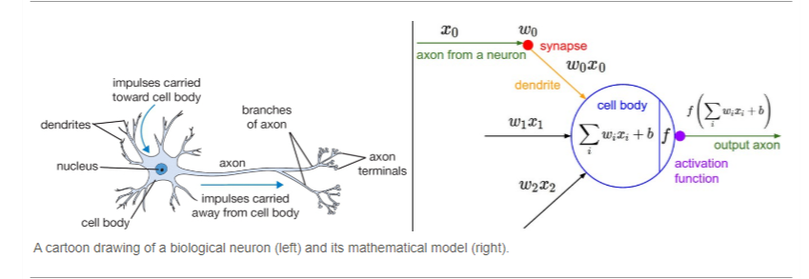

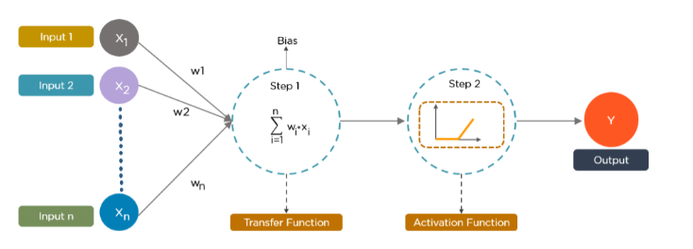

**What is an activation function and why to use them?**

**Definition of activation function: -**Activation function decides, whether a neuron should be activated or not by calculating weighted sum and further adding bias with it. The purpose of the activation function is to **introduce non-linearity** into the output of a neuron.

**Explanation: -** We know, neural network has neurons that work in correspondence of weight, bias and their respective activation function. In a neural network, we would update the weights and biases of the neurons on the basis of the error at the output. This process is known as **back-propagation**. Activation functions make the back-propagation possible since the gradients are supplied along with the error to update the weights and biases.

Some activation functions name:

1. Threshold
2. Sigmoid
3. Tanh
4. Relu (Retified linear unit)
5. Leaky relu
6. Softmax (Use for Multiclass classification)
7. Softplus
8. P-relu
9. Elu

Types of Algorithms used in Deep Learning

**Here is the list of top 10 most popular deep learning algorithms:**

1. Convolutional Neural Networks (**CNNs**)
2. Long Short-Term Memory Networks (**LSTMs**)
3. Recurrent Neural Networks (**RNNs**)
4. Generative Adversarial Networks (**GANs**)
5. Radial Basis Function Networks (**RBFNs**)
6. Multilayer Perceptron’s (**MLPs**)
7. Self-Organizing Maps (**SOMs**)
8. Deep Belief Networks (**DBNs**)
9. Restricted Boltzmann Machines (**RBMs**)
10. Autoencoders

**Supervised Learning:**

* Artificial Neural Network (**ANN**)
* Convolutional Neural Network (**CNN**)
* Recurrent Neural Network (**RNN**)

**Unsupervised Learning:**

* Boltzmann Machine VS Deep BM
* Self-Organizing Maps (**SOMs**)
* Autoencoder

**Reinforcement Learning:**

* GAN (**Generative Adversarial network**)
* Deep Q Learning

**What is Optimizer?**

**Ans:** Optimizer are algorithms or methods used to minimize an **error function** or **loss function** and maximize the efficiency of production. Optimizer are mathematical functions which are dependent on model’s learnable parameters i.e., Weights and Biases. **In short optimizer use for decrease the loss of the model.**